Green Society Public School
D-12
Ratnanagar-7, Sauraha, Chitwan
Annual Examination-2082
Class: UKG Time: - 2 hrs. F.M.: 50
Sub: English ‘O’
Hello! Good Morning/Good Afternoon
How are you?
1. What is your name? 5
2. How old are you? 5
3. What is your class teacher's name? 5
4. What is your incharge's name? 5
5. What is your principal's name? 5
6. What is our national animal's name? 5
7. Read the given letters. 10
Qq Rr Ss Tt Uu
Vv Ww Xx Yy Zz
8. Identify the pictures. 5

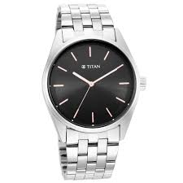

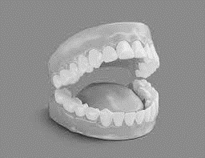
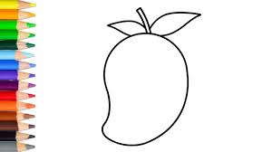

9. Neat and clean. 10
The End

